INTRODUTION

1.1 overview

Keep reading to find out how to create a smart visual content strategy for social media while text can be a great tool for communicating

1.2 purpose

The purpose of social media posts is to increase brand awareness and visibility the more people know about your social media presence the people you can potentially turn into customers social media posts also help in building relationship with your audience when they engage with your posts

Problem Definition & Design Thinking

2.1 Empathy Map

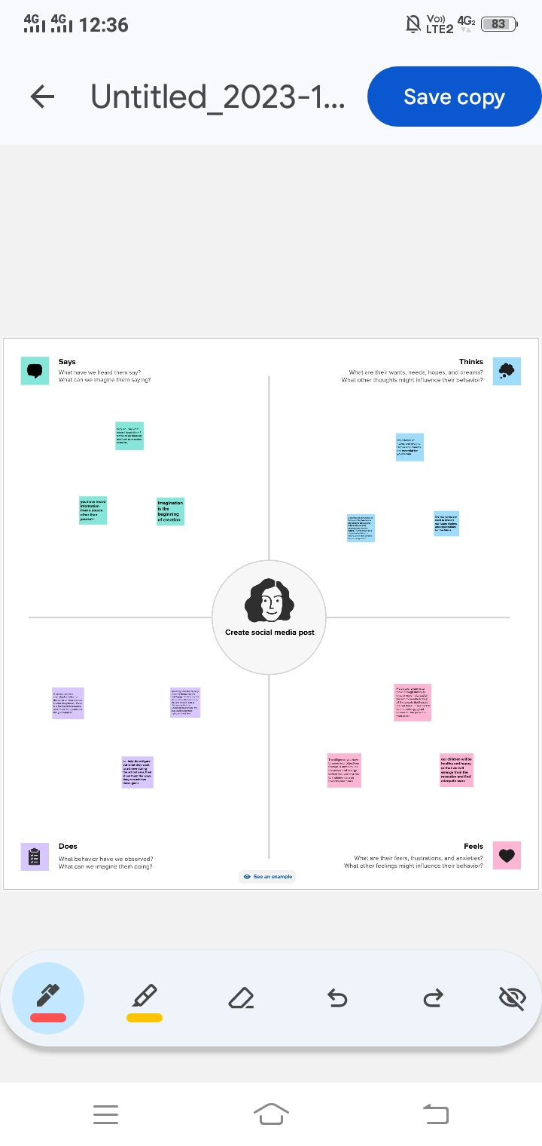

2.2 Ideation & Brainstorming map

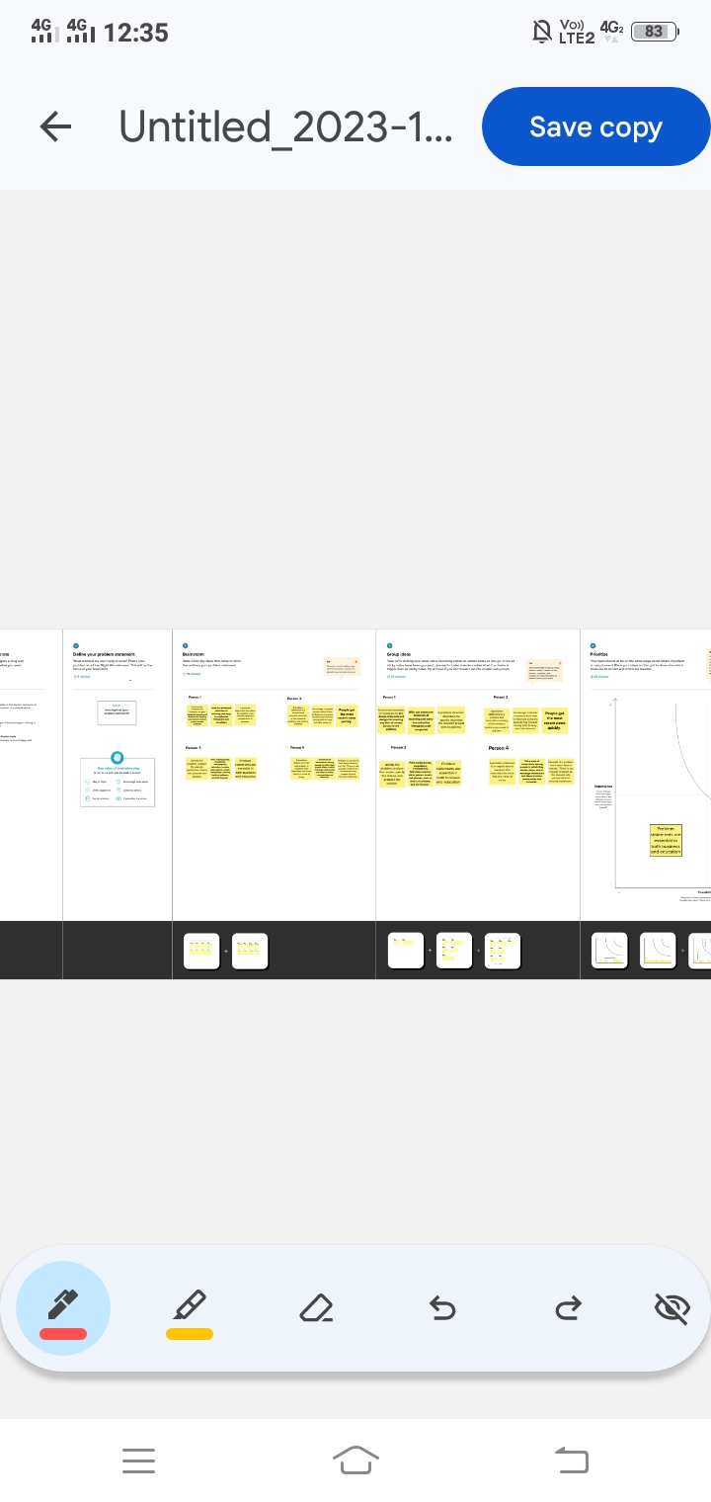

**3 RESULT**

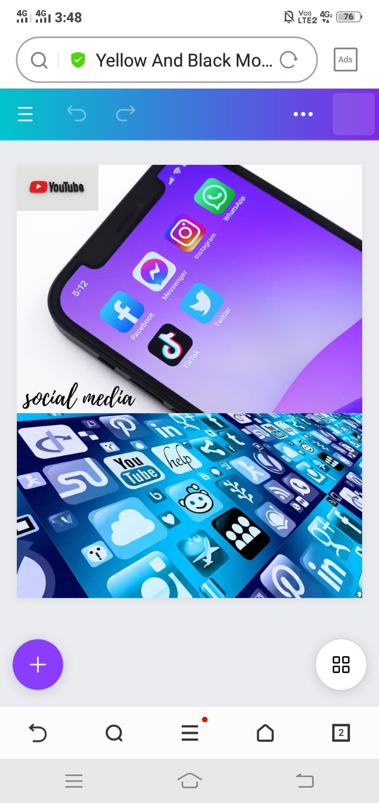

4 ADVANTAGES & DISADVANTAGES

**4.1 Advantages**

 share relevant information or content with this audience, which is helpful if you want people to follow you on social media.

 Sharing content on social media can help you gain followers who will then be interested in what you have to say.

 Millions of people use social media every day, making it easier for businesses like yours to find potential customers online.

**4.2 Disadvantages**

Social media is addictive and can consume your time if you don’t have any other interests. It would help if you kept up with your studies and hobbies to stay productive.

Social media makes us more self-centered and less empathetic towards others. It also makes us more narcissistic than ever because we can show off our achievements and post photos from parties without facing any consequence

People who are not confident in their skills may feel inferior when they post something on social media, which can lead to low self-esteem and depression.

**5 APPLICATIONS**

I have used Mural application and Canva application

**6 Conclusion**

We have created social media post with the help of Canva

**7 FUTURE SCOPE**

We were planning to join the Graphic Designing course